Benchmark - Active Directory Lab

Ryan Coon

CYB-515

Dr. Edward Marchewka

September 18, 2024

Part 1:

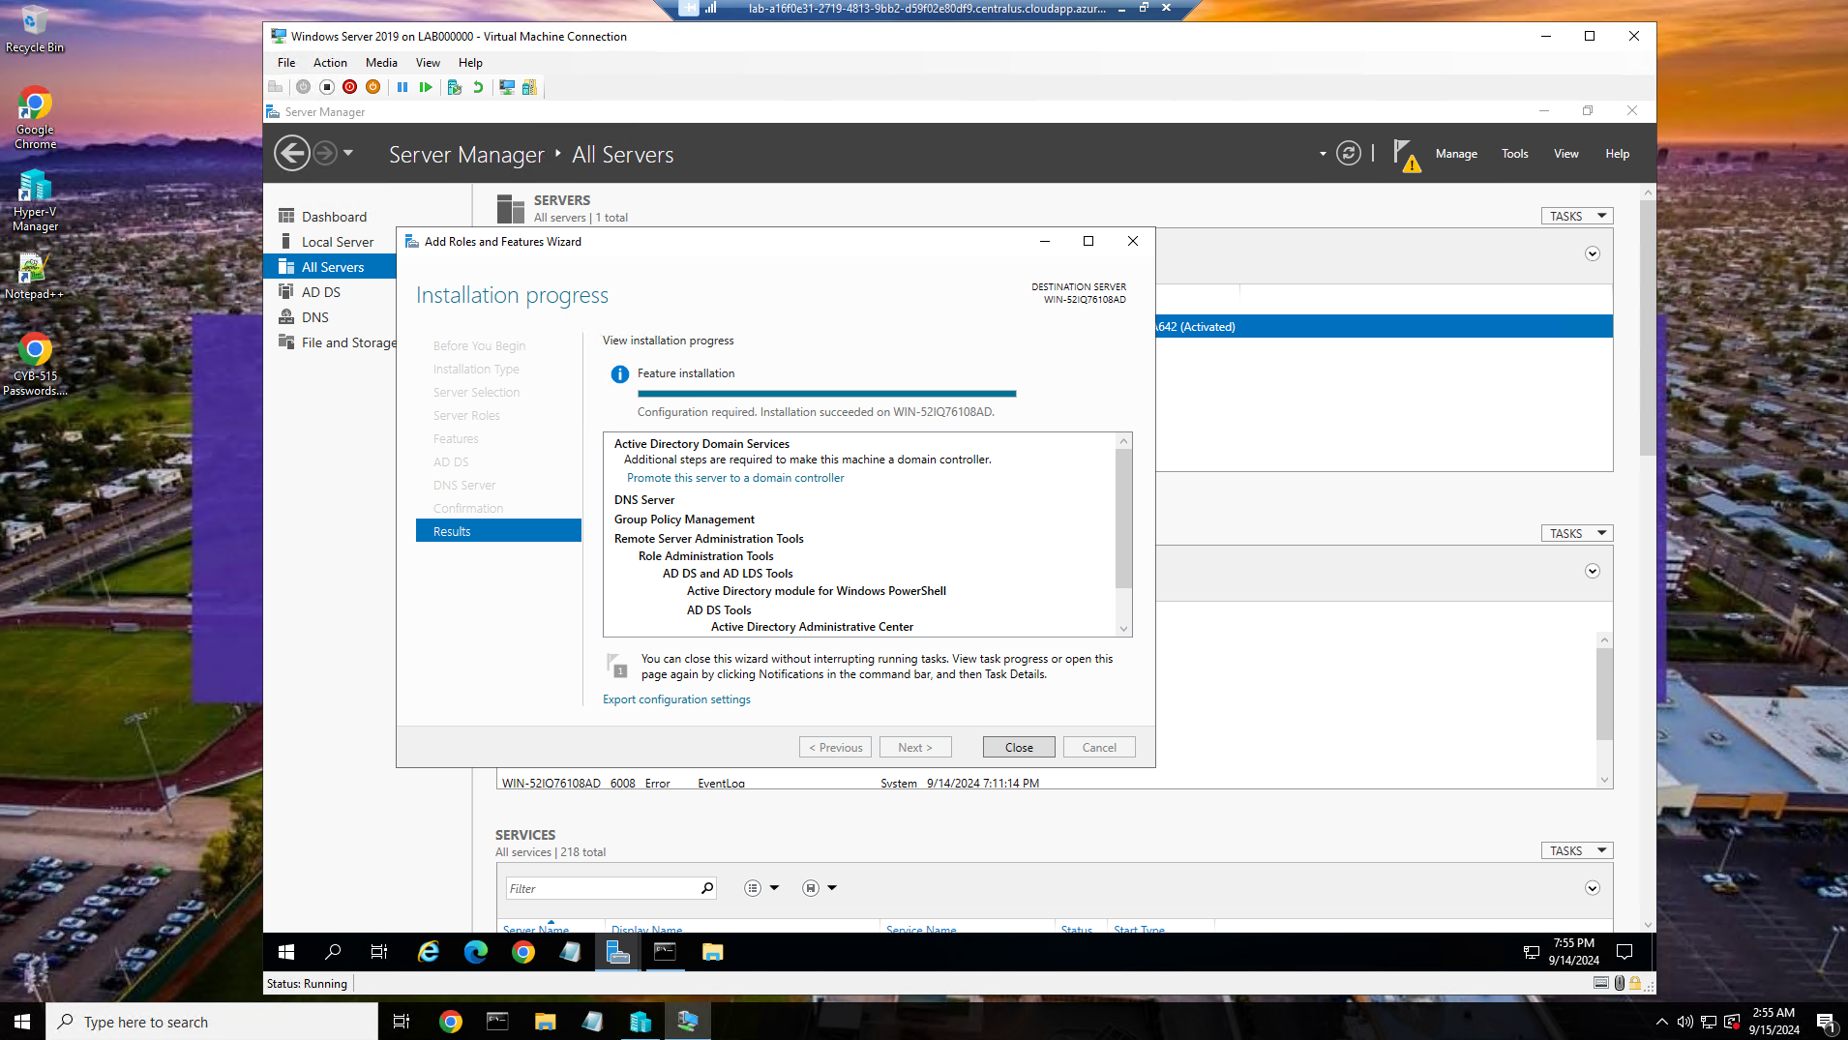

Installation of AD onto Windows server

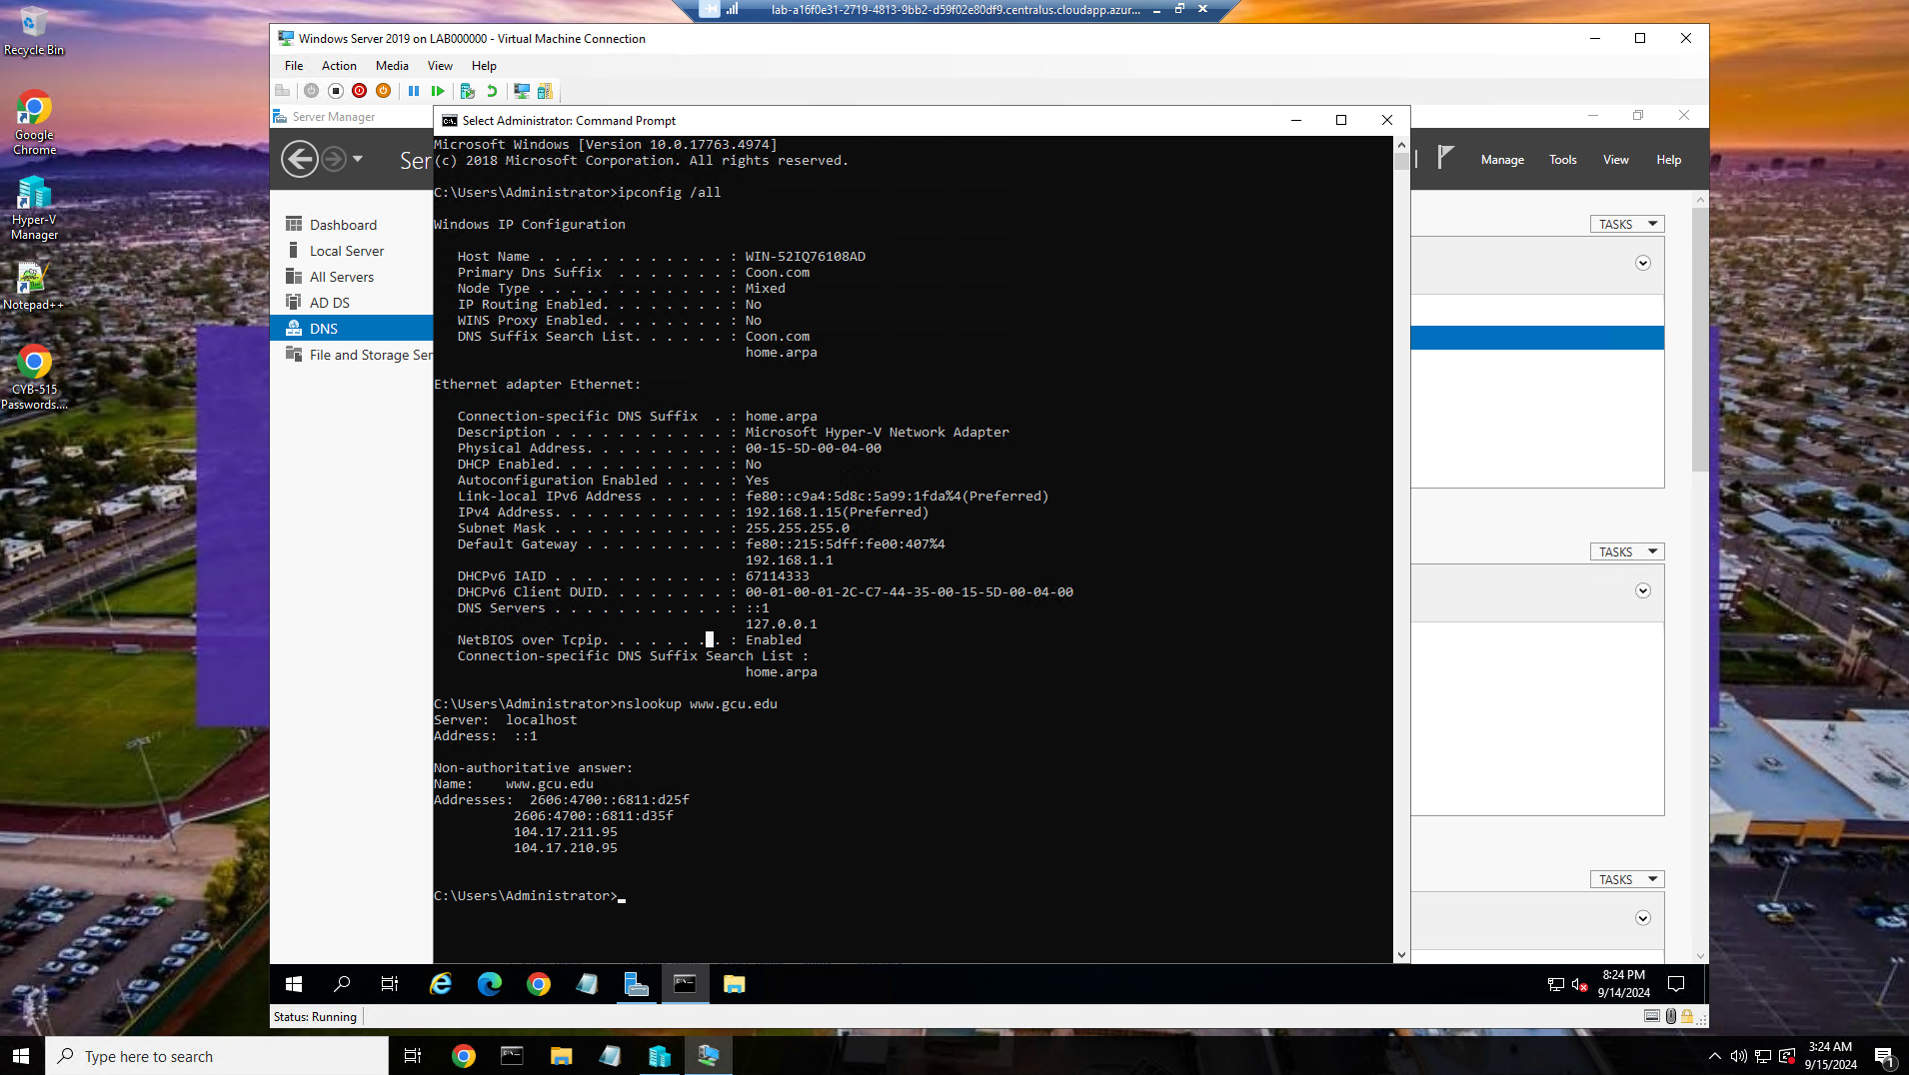

Successful installation of AD. Notice DNS suffix of Coon.com

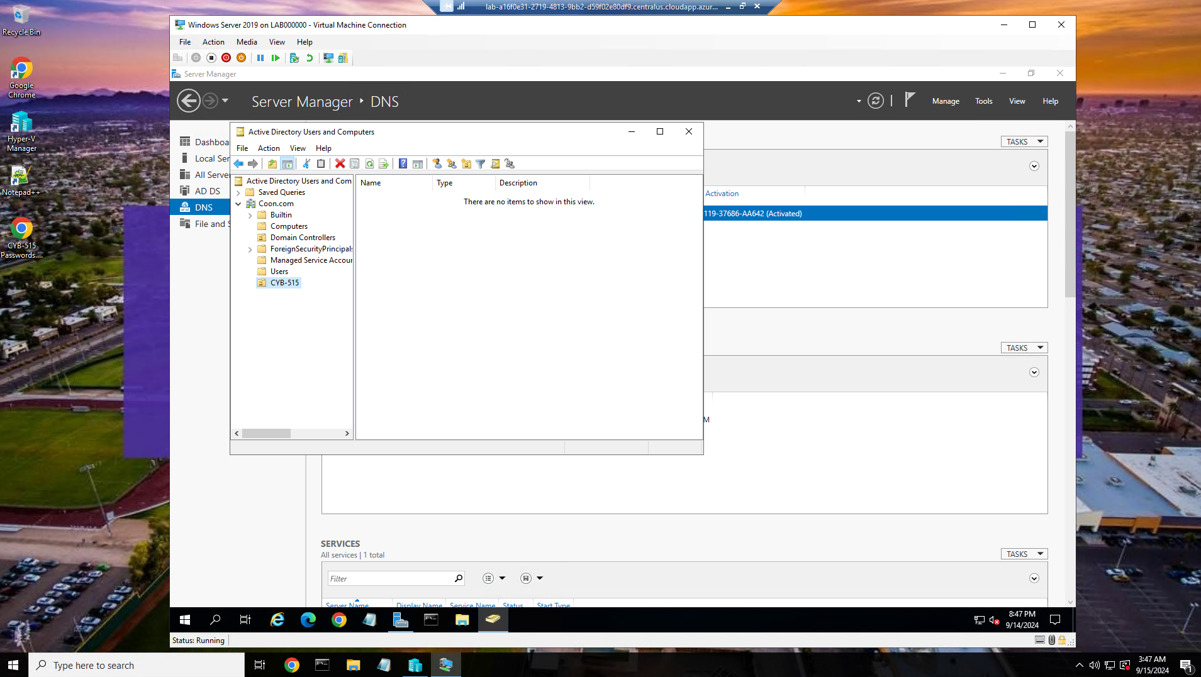

Successful creation of an Organizational Unit named CYB-515 within the root domain.

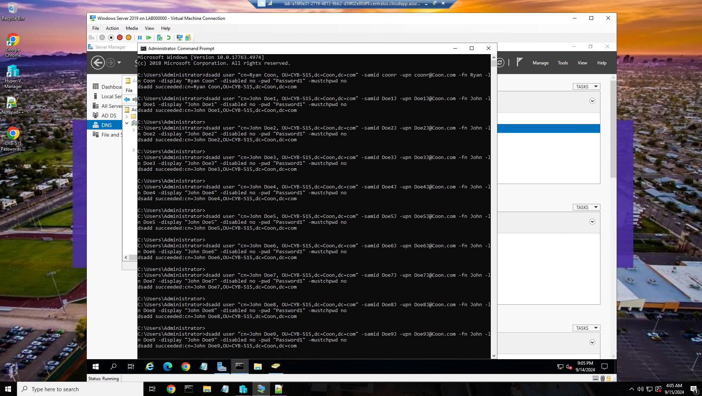

Successful creation of 10 users inside the CYB-515 Organizational Unit using Command Prompt. 1st user is created with my first and last name.

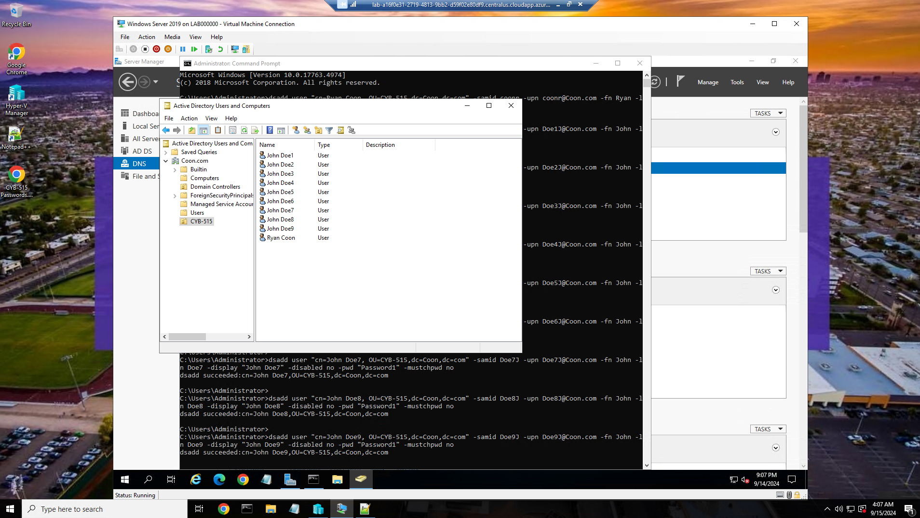

Better visual of users added into the CYB-515 Organizational Unit.

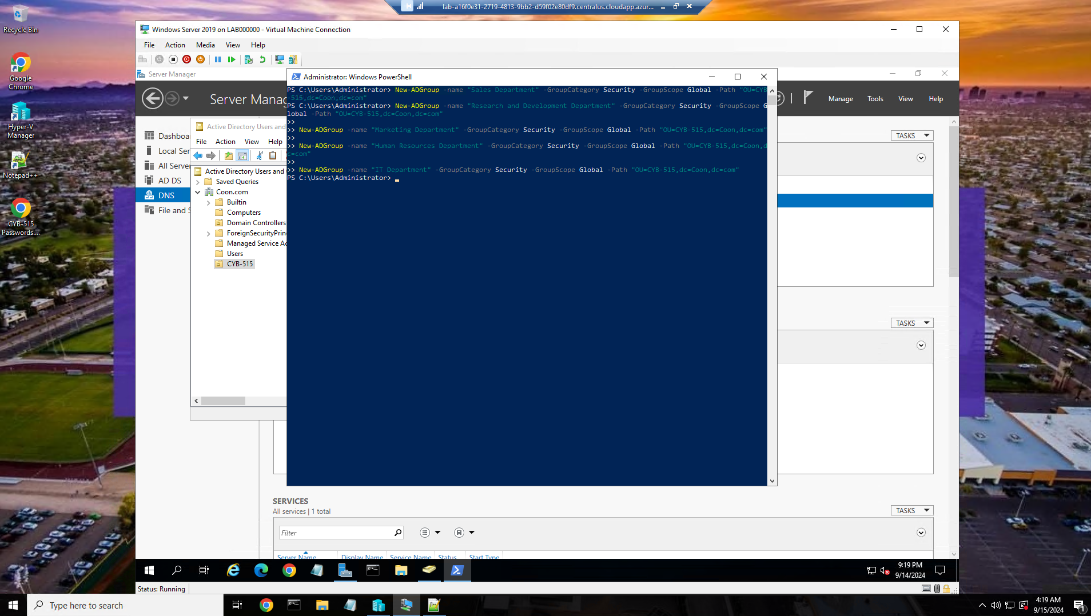

Successful addition of the 5 predetermined groups into the CYB-515 Organizational Unit using Power Shell

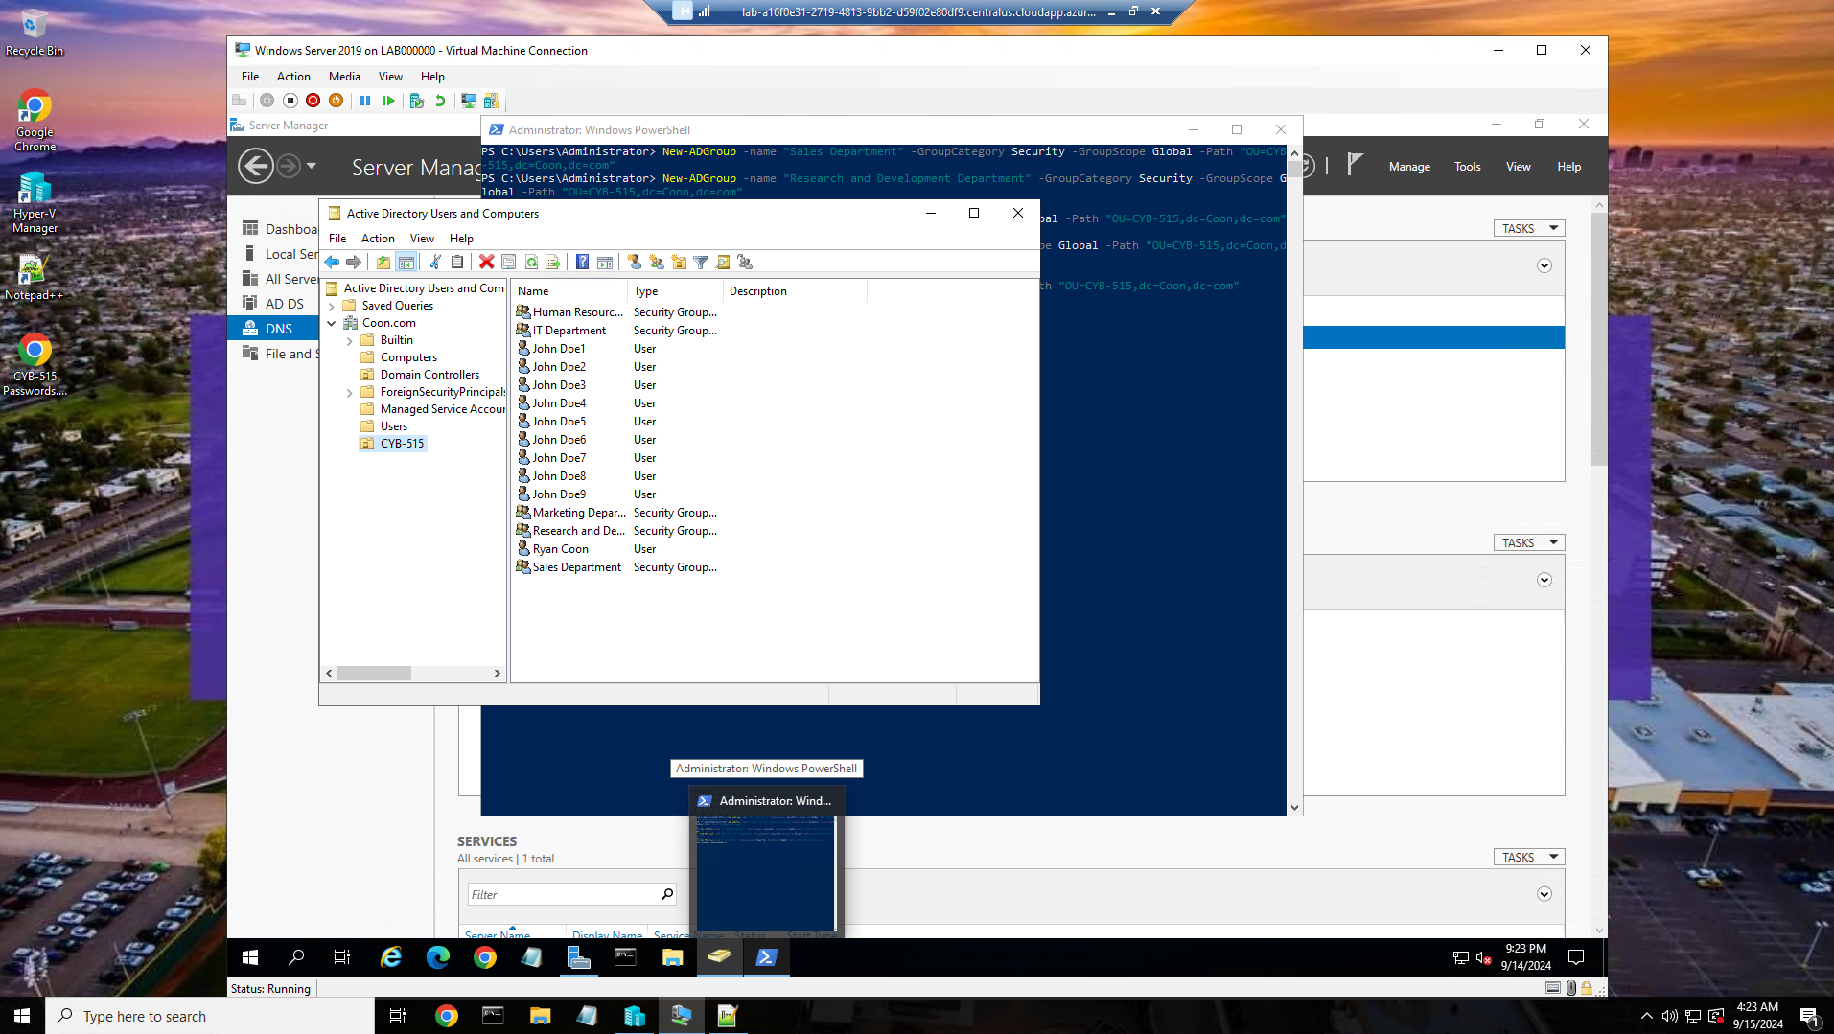

Better visual of the groups that were added.

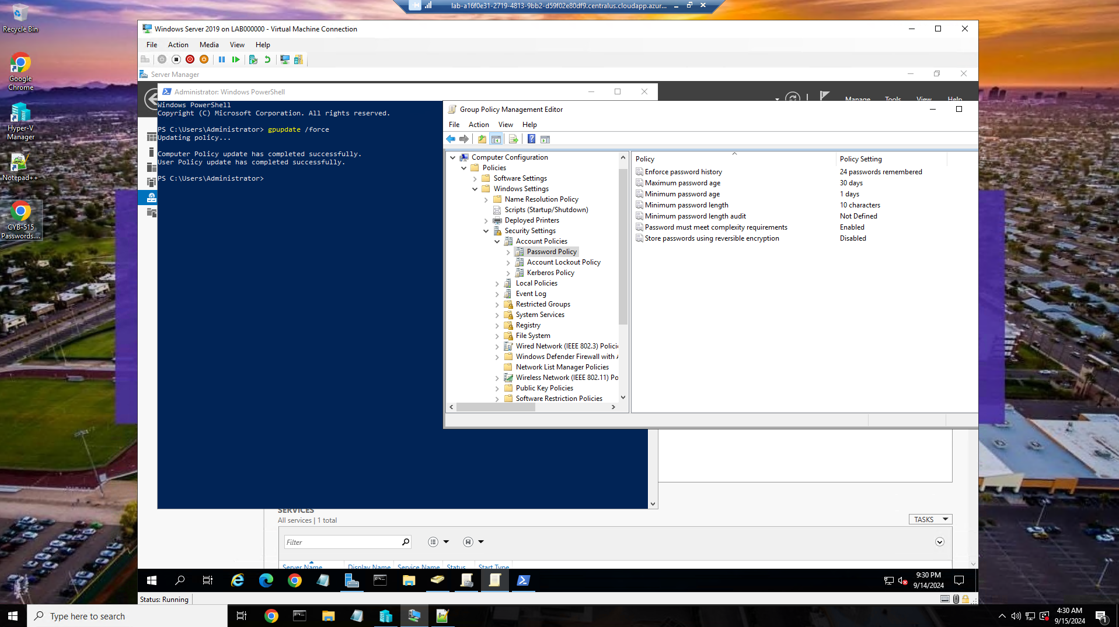

Implemented custom password policies to the Active Directory for the 5 groups in the Coon Domain

Part 2:

**Identify vulnerabilities and risks to an organization's critical infrastructure if access control is not implemented.**

If access control mechanisms are not implemented, organizations face significant vulnerabilities and risks to their critical infrastructure. These may include unauthorized access, data integrity issues, service disruptions, and compliance violations. Without proper controls, malicious actors can gain access to sensitive systems and data, leading to potential data breaches, theft, or sabotage. In the absence of access controls, unauthorized users may alter or corrupt critical data, undermining the integrity of operations and decision-making. Attackers can disrupt services, leading to operational downtime, financial loss, and damage to reputation. Lack of access control can result in non-compliance with industry regulations, leading to legal repercussions and financial penalties.

**Describe why each principle of access control is important to security and how it enables the development of security mechanisms that can implement desired security policies, as it relates to Active Directory.**

The principles of access control are Authentication, Authorization, Accountability, and Auditing and are crucial for security within an Active Directory.

Authentication - Establishes the identity of users trying to access the system. It ensures that only legitimate users can gain access, thereby preventing unauthorized access.

Authorization - Determines what authenticated users are allowed to do. This ensures that users only have access to the resources necessary for their roles, thereby minimizing the risk of data exposure.

Accountability - Involves tracking user activities through logs. This principle ensures that actions can be traced back to users, which deters malicious behavior and aids in investigations.

Auditing - Regularly reviewing access logs and permissions helps identify anomalies and potential security breaches, allowing organizations to respond proactively.

**Analyze workstations, servers, appliances, mobile devices, and/or peripheral devices in an enterprise network. Identify two common security failures and the specific design principles that have been violated.**

Two common security failures include:

Weak Password Policies - This violation of the Security Principle of Least Privilege allows users to access more than they need, increasing the risk of unauthorized entry.

Inadequate Patch Management - Failing to update software can lead to vulnerabilities being exploited. This violates the Defense in Depth principle, as layered security measures are not properly maintained.

**Describe the basic security implications of modern computing environments.**

Modern computing environments introduce several security implications, including:

Increased Attack Surface - With the proliferation of devices and cloud services, there are more entry points for attackers.

Data Breaches - The potential for sensitive data exposure has increased due to poor security practices and unregulated data sharing.

Complexity of Management - Managing security across diverse platforms and devices complicates the implementation of consistent security policies.

**Discuss how to develop efficient and effective system solutions to safely secure digital assets and intellectual property.**

To develop efficient and effective system solutions for securing digital assets and intellectual property, organizations should:

Implement Role-Based Access Control (RBAC) - This allows for assigning permissions based on user roles, thereby minimizing unnecessary access.

Regularly Update and Patch Systems - Ensuring that all systems are up-to-date reduces vulnerabilities.

Conduct Security Audits - Regular assessments enable organizations to identify weaknesses and improve security measures.

**Describe four hardware components of modern computing environments and discuss the individual functions of each component. Explain which would be the easiest to secure and why.**

Processors (CPUs) - Execute instructions and perform calculations. They are essential for the overall performance of a system.

Memory (RAM) - Temporarily stores data and instructions for quick access. It is critical for system speed and responsiveness.

Storage Devices (HDD/SSD) - Store data permanently. SSDs are generally faster and more reliable than HDDs.

Network Interface Cards (NICs) - Enable communication between devices on a network. They are crucial for connectivity and data transfer.

Among these, Storage Devices are often the easiest to secure due to the ability to implement encryption and access controls at the storage level.

**Identify the secure design principles involved or needed in the creation of user accounts while ensuring the principle of least privilege.**

When creating user accounts users should only have access to the information necessary for their work. Tasks should be divided among multiple individuals to reduce the risk of fraud or error. Periodic audits of user access rights help ensure compliance with security policies.

**Explain how virtualization is different in the Windows and Linux operating systems.**

Windows - Primarily uses Hyper-V as its built-in hypervisor for virtualization, which integrates tightly with Windows Server and offers features like live migration and virtual machine replication. Hyper-V supports both Type 1 (bare-metal) and Type 2 (hosted) virtualization. Provides a user-friendly GUI for managing virtual machines (VMs) through the Hyper-V Manager.

Linux – Commonly utilizes KVM (Kernel-based Virtual Machine) as its primary hypervisor. KVM is a Type 1 hypervisor integrated into the Linux kernel, allowing Linux to act as a hypervisor. Other popular options include Xen and QEMU, which can work with KVM for enhanced functionalities

References:

Billmath. (2023, August 15). Access Control Policies in AD FS Windows Server 2016. Learn.microsoft.com. https://learn.microsoft.com/en-us/windows-server/identity/ad-fs/operations/access-control-policies-in-ad-fs

Computer Hardware: Definition and Components. (2024, September 11). IT Asset Management Group. https://www.itamg.com/it-asset/hardware/computer/

Learn how to identify, secure, manage, monitor, and innovate with your digital assets to create value and competitive advantage for your business. (2023, September 26). Linkedin.com. https://www.linkedin.com/advice/3/how-can-you-protect-your-digital-assets-from

McCarthy, M. (2023, September 13). Principle of Least Privilege (PoLP) | What is it & Why is it important | strongDM. Www.strongdm.com. https://www.strongdm.com/blog/principle-of-least-privilege

Office, U. S. G. A. (2023, February 7). Cybersecurity High-Risk Series: Challenges in Protecting Cyber Critical Infrastructure. Www.gao.gov. https://www.gao.gov/products/gao-23-106441

Puzas, D. (2023, January 26). 9 Cloud Security Risks, Threats & Challenges | CrowdStrike. CrowdStrike. https://www.crowdstrike.com/cybersecurity-101/cloud-security/cloud-security-risks-threats-challenges/

Stallings, W. (2018). Operating systems : internals and design principles. Pearson.

taryntaylor. (2023, June 13). Six ways to apply the principle of least privilege to your Active Directory. Specops Software. https://specopssoft.com/blog/six-ways-to-apply-the-principle-of-least-privilege-to-your-active-directory/

The Inevitability of Failure: The Flawed Assumption of Security in Modern Computing Environments. (n.d.). Cryptome.org. https://cryptome.org/jya/paperF1.htm

Top 10 Strategies for Managing Digital Assets | Catsy. (2023, March 6). Product Information Management. https://catsy.com/blog/top-10-strategies-for-managing-digital-assets/

What are critical infrastructure cyber security vulnerabilities and threats? (n.d.). Www.linkedin.com. https://www.linkedin.com/pulse/what-critical-infrastructure-cyber-security-vulnerabilities

What is the Difference Between Linux and Windows? (n.d.). Linode Guides & Tutorials. https://www.linode.com/docs/guides/linux-vs-windows/

(2022). Giac.org. https://www.giac.org/paper/gsec/1436/violations-basic-computer-security-principles-television-broadcast-community-suggested-solutions/102672